Employment History

CURRICULUM VITAE
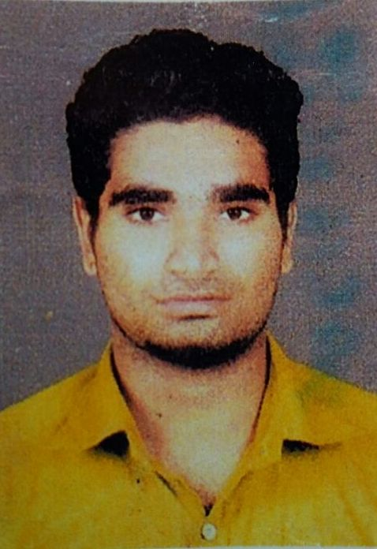

MOHAMMED FASIL .K

E-mail

fasilfazza@gmail.com

Phone

Mob: 0091 – 9633768866

Mob:0091-7907700901

Personal Details

Date of Birth

9th August 1995

Gender

Male
Nationality

Indian

Marital Status

Un Married

Languages

English, Hindi, Malayalam

Address

ERNAKULAM
KERALA
INDIA

Career Objective
To acquire a proactive and challenging role that would provide strong developmental opportunities and balanced application to the prevalent practices in the fields of Bachelor of Commerce and construction could be utilized for mutual benefits. A Graduate in the field of Bachelor of Commerce, Having Two Years of experience in the Sales & Customer Service field Seeking a suitable position to utilize my skills, experience and abilities to fullest in the industry that offers challenges, security and professional growth while being resourceful, innovative and flexible.

Profile In Brief
Having Two Years of Experience in Sales,Cashier,Documentation & Customer service
- Well experienced in Sales & Cashier.
- Excellent in Customer Service
- Able to work under pressure.
- Hard working and result oriented.
- Having very good command over spoken and written English.
- Having very good Computer Knowledge.
- Having good knowledge of General Accounts.
- Having interpersonal and Public Relation Skill.
- Having strong sense of responsibility.
- Fast learner, Adapt well to changes and welcome challenges at workplace.

Academic Credentials
Graduation Level : - Bachelor of Commerce

University : - Mahatma Gandi University Kerala

Year of Passing : - 2016

Plus Two : - Commerce

Board : - Board of Higher Secondary Examination
Government of Kerala

Year of Passing : - 2013

Technical Credentials
- Well versed with MS-Office and Word & fair Hardware and Software knowledge
- Basic computer & Internet knowledge & Dealer Manager System, Quick Books,
- Internet Buffering and E-Mail checking & Computerized Accounting
- Data Entry Management

►LKAY Insurance Surveyor Co.

►SHILPAKALA at LULU Mall Edappally

►HPCL- drive track plus
Company Profile: -
A leading Surveyor company of Insurance in Kerala.
A leading Marketing company of Handicrafts in Kerala.
A leading petroleum company (petro cards)
Position: - Documentation, Sales , Cashiers & customer executive

Duties & Responsibilities: -

- Provides financial information to management by researching and analyzing accounting data; preparing reports
- Prepares asset, liability, and capital account entries by compiling and analyzing account information.
- Documents financial transactions by entering account information. Recommends financial actions by analyzing accounting options.
- Summarizes current financial status by collecting information; preparing balance sheet, profit and loss statement, and other reports.
- Substantiates financial transactions by auditing documents. Maintains accounting controls by preparing and recommending policies and procedures.
- Guides accounting clerical staff by coordinating activities and answering questions. Reconciles financial discrepancies by collecting and analyzing account information.
- Secures financial information by completing data base backups. Maintains financial security by following internal controls.
- Prepares payments by verifying documentation, and requesting disbursements.
- Answers accounting procedure questions by researching and interpreting accounting policy and regulations.
- Complies with federal, state, and local financial legal requirements by studying existing and new legislation, enforcing adherence to requirements, and advising management on needed actions.
- Prepares special financial reports by collecting, analyzing, and summarizing account information and trends.
- Maintains customer confidence and protects operations by keeping financial information confidential.
- Maintains professional and technical knowledge by attending educational workshops; reviewing professional publications; establishing personal networks; participating in professional societies. Accomplishes the result by performing the duty. Contributes to team effort by accomplishing related results as needed
- Receive payment by cash, check, credit cards, vouchers, or automatic debits. Issue receipts, refunds, credits, or change due to customers. Count money in cash drawers at the beginning of shifts to ensure that amounts are correct and that there is adequate change.
- Greet customers entering establishments. Maintain clean and orderly checkout areas. Establish or identify prices of goods, services or admission, and tabulate bills using calculators, cash registers, or optical price scanners.
- Issue trading stamps, and redeem food stamps and coupons.
- Resolve customer complaints. Answer customers' questions, and provide information on procedures or policies.
- Cash checks for customers. Weigh items sold by weight in order to determine prices.
- Calculate total payments received during a time period, and reconcile this with total sales. Compute and record totals of transactions.
- Sell tickets and other items to customers. Keep periodic balance sheets of amounts and numbers of transactions.
- Bag, box, wrap, or gift-wrap merchandise, and prepare packages for shipment. Sort, count, and wrap currency and coins. Process merchandise returns and exchanges.
- Pay company bills by cash, vouchers, or checks. Request information or assistance using paging systems.
- Stock shelves, and mark prices on shelves and items. Compile and maintain non-monetary reports and records. Monitor checkout stations to ensure that they have adequate cash available and that they are staffed appropriately.
- Post charges against guests' or patients' accounts. Offer customers carry-out service at the completion of transactions.

Declaration
I am confident that I can add a new mile stone in my respective field with full dedication and commitment. I solemnly declare that all information furnished above is true and actual to the best of my knowledge and belief.

Place:-
Date: - MOHAMMED FASIL .K

